SATELLITE IMAGE MAPS FOR THE AUSTRIAN ARMED FORCES -DESIGN, PRODUCTION AND SOME EDITORIAL AND TECHNICAL PROBLEMS

Robert Ditz

Institute of Military Geography, Ministry of Defence, Vienna, Austria

kdofueu.img.karto@bmlv.gv.at

Abstract
Satellite image maps complemented with lettering and further cartographic elements have an immense benefit, compared with conventional topographic maps. The production of such maps is a challenge, especially concerning the cartographic design. This article presents some information about the production and the design of satellite image maps. As well, some occurring editorial and technical problems were illustrated, and some solutions discussed.

1 Introduction
One of the products produced at the Institute of Military Geography are Military Fact Sheets of countries, interesting due to their political and military situation and/or the commitment of the Austrian Armed Forces. These fact sheets present the geography, the political and the cultural situation, and give some practical information about the language, the behaviour and some useful addresses of the selected countries.

Beside some thematic maps produced for the fact sheets, in 2005 the Institute of Military Geography started to produce satellite image maps of the capital city as a supplement of these printed fact sheets. Since this was the first 'prototype' of such a satellite image map, the production was accompanied by some problems and challenges, so that helpful experiences could be picked up for further map productions. Generally, this is a permanent evolutionary process with slightly changes from one map to another.

2 Satellite Images
The satellite images used to produce the maps are high-resolution images from satellites like QUICKBIRD or IKONOS. The main problem when using satellite images is the problem of mosaicking different image scenes. The problems that occur are different illumination conditions as a result of different moments of shooting and geometric failings. Figure 1 shows two examples at the scale of 1 : 2 000 of such geometric deficiencies and the result of mosaicking using a cutline (shown in red).

The cutline was manually digitized so that the unevenly occurred distortions are almost not perceptible. The result of the mosaicking, shown on the right side of figure 1, presents one more rail of the railway (upper series) and one more lane of the road (lower series). Regarding the scale of the final map, these deficiencies are neglectable. Problems of noise in images, due to irregularities or errors in the sensor response and/or data recording and transmission (Wechselberger, 2006), are also neglectable and have not been corrected.

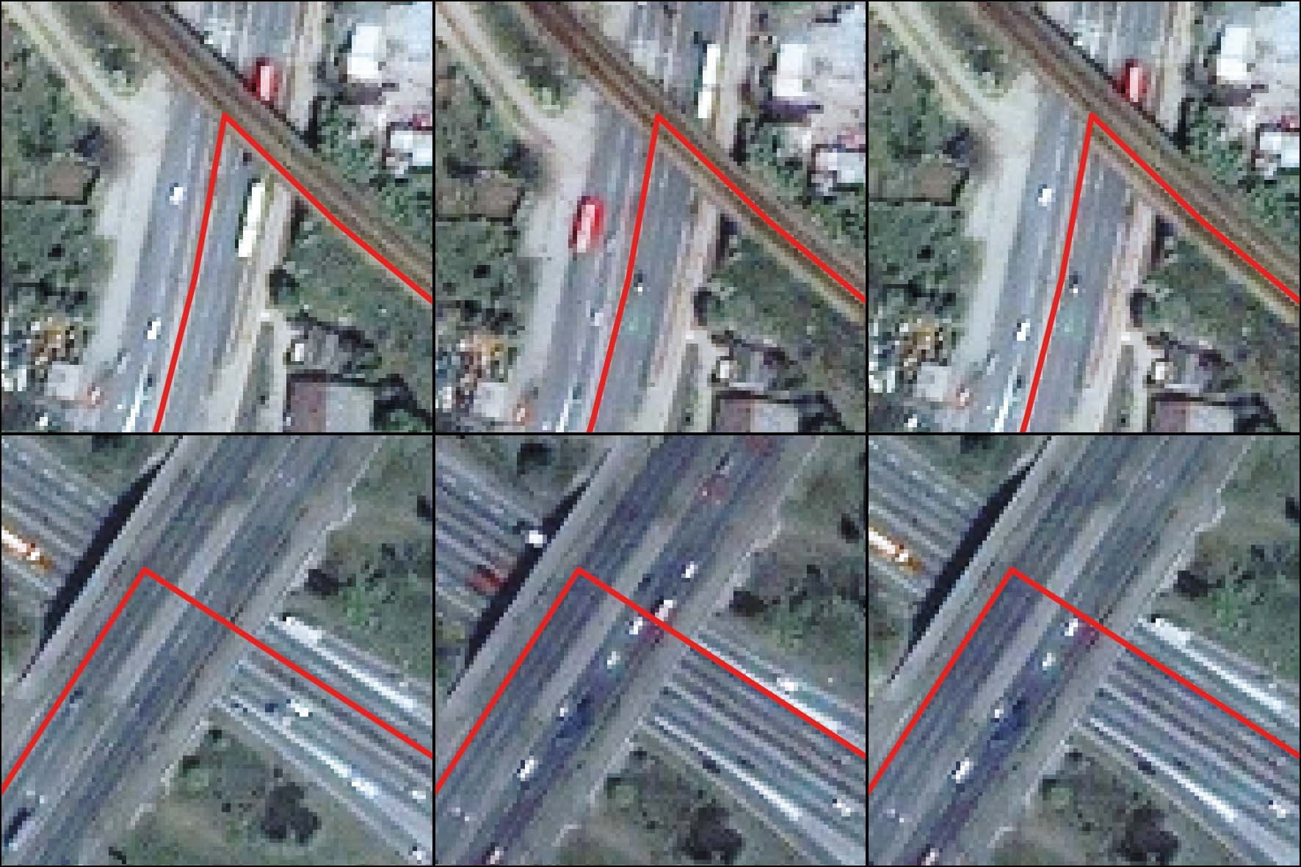
Figure 1: Mosaicking of image scenes and the problem of geometric deficiencies

Problems of different illuminations occur when several satellite images from satellites like LANDSAT are used to create maps covering a large area of interest in a small scale. Images shot at the same time of the year and the day, with nearly no clouds, would be desirable. Even different atmospheric conditions have an influence on the contrast of images shot at the same day (Kudola, 2000). The coverage of clouds on a satellite image should be under 10% (Hof 2007), on images of the IKONOS satellite a coverage up to 20% can be expected (Meine et al., 2001), and this although the availability of satellite images is very unequal over the years, the months and the seasons.

The automatic colour correction may not produce the desired results, so that a manual adaptation is necessary, as discussed later in this article. Further manual corrections of picture elements like clouds, only available and seen in one image scene, are also possible (Albertz et al., 1992). It is also useful to enhance the satellite image quality, concerning the colour characteristics like hue, value and saturation, and the colour contrast to obtain a pleasing image for printing. The left side of figure 4 shows a detail of the satellite image of Khartoum without image enhancement, whereas the right side shows the same detail improved for the second edition of this map.

3 Production Workflow
The production of satellite image maps makes the use of many different programs necessary, as shown in figure 2. The programs here presented are only one opportunity for the preparation. There are many other programs with the same functionality and possibilities to perform the same tasks.

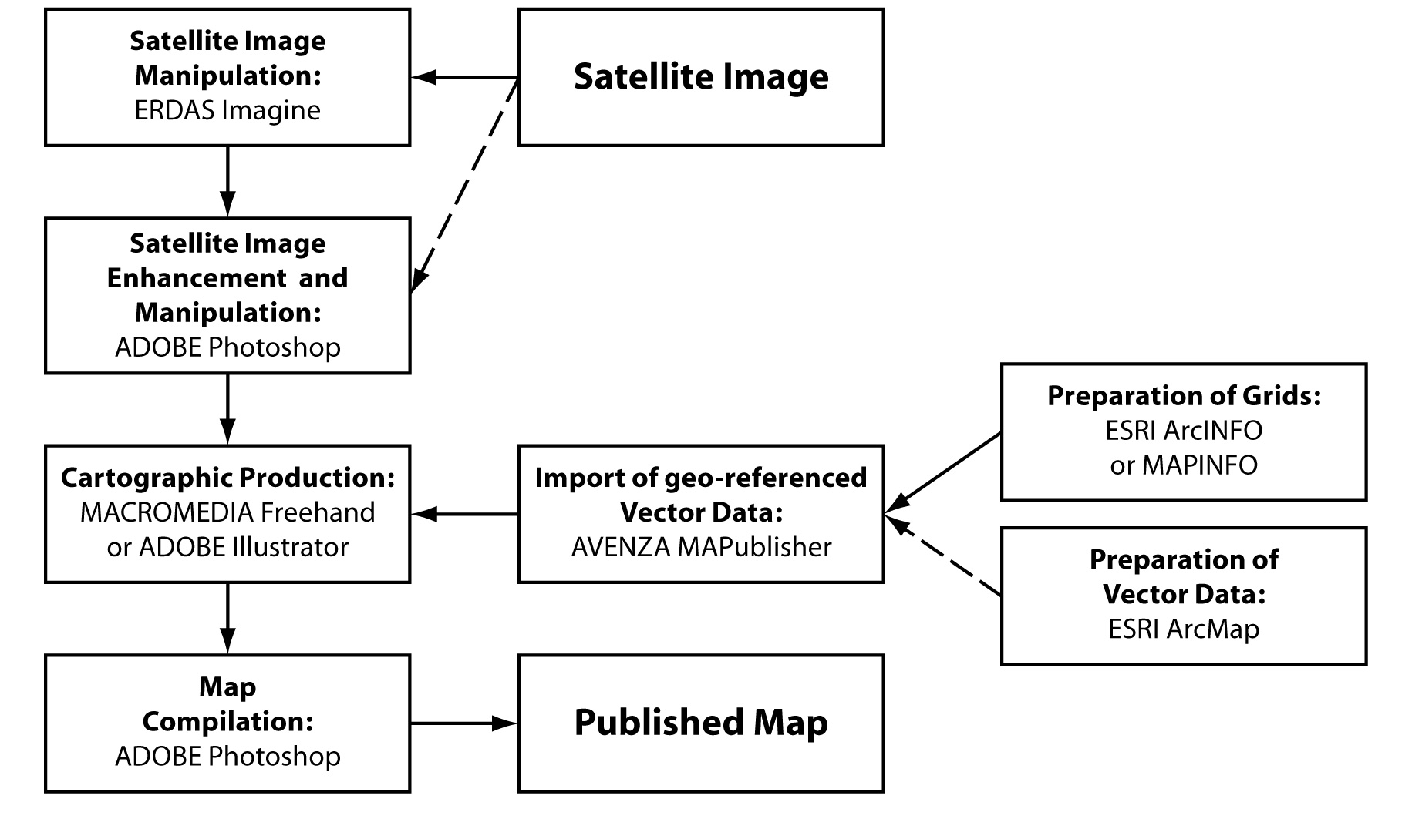
Figure 2: Cartographic workflow for the map production

For the first preparation of satellite images, ERDAS Imagine is used to combine the three visual bands (R, G and B) of the images, and to mosaic different image scenes, as long as they are shot at the same time. This program is also used to clip the image to the actual boundaries used in the map. The program ADOBE Photoshop can be used to enhance the quality of the satellite image, as already described in the chapter before. It is also used to convert the satellite image into CMYK for the cartographic map production.

If geo-referenced vector data are available, they can be prepared in a GIS-program like ESRI ArcMap. The necessary tasks to be performed are the projection and the clipping of the data to the actual data frame. The geographic and the UTM grid are prepared either in MAPINFO and then transformed in the ESRI shape format, or directly in ESRI ArcINFO. To get the data geo-referenced into a vector drawing program like MACROMEDIA Freehand or ADOBE Illustrator, the Plug-In MAPublisher from AVENZA is used. With this tool the scale, the projection and the placement of the data within the map document of the graphic program is done. The cartographic design of the map can afterwards be continued after importing the geo-referenced data.

In spite of higher computing performances it is useful to load the satellite image with a lower resolution (for instance with 150 dots per inch) to obtain a fast processing within the vector program. The cartographic map production is finished with the export of the vector data in an EPS-format, and then finally joined together with the high-resolution satellite image in ADOBE Photoshop.

4 Cartographic Design
At the beginning of the project 'Satellite Image Maps' no restrictions concerning form and content were made. After finishing the prototype, some improvements and adaptations had to be done. The most far-reaching change of the following maps having an impact on the general layout was the reduction of the size to enable a machine-made folding at a bookbinder's, while the prototype map was manually folded by staff of the Federal Agency of Metrology and Surveying. Another modification concerning the design was the creation of an overview map of the city (Belgrade, Kinshasa, Rabat), an overview map of the country (Tirana, Rabat), and auxiliary maps of the airport (Kinshasa, Rabat) on the reverse side of the map.

The layout of the satellite image maps, as shown in figure 3, orientates itself on the general layout of the topographic maps of the Austrian Armed Forces concerning the design of the cover and the framework. Further elements of the margin are the legend, an overview map with grid zone designations, an example of a position report for an object, the list of embassies and representations, a scale bar, the used sources and the imprint. The satellite image maps at the scale of 1 : 5 000 up to 1 : 10 000 have an UTM-projection with an UTM and a geographic grid and the appropriate lettering on the margin, and the lettering of the 100-km squares.

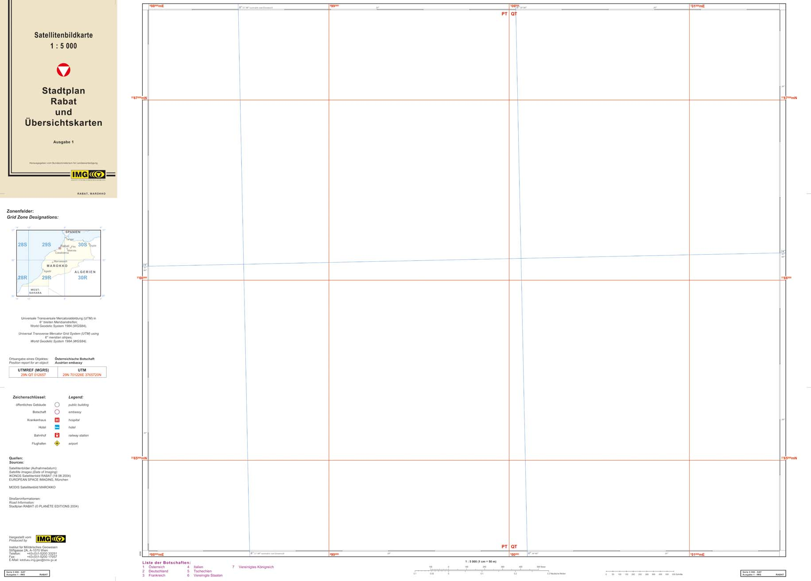
Figure 3: Standard layout of the satellite image maps

The nature of a satellite image map is the 'objective' photographic character which could be supplemented by cartographic elements (Kelnhofer, 1985). This combination of images and all means of cartographic expressions increase the possibility of gathering information (Hoffmann et al., 2000). The art of making a satellite image map is to reduce landmarks and further topographic elements to a minimum (Albertz et al., 1992, Beckel et al., 2006) to avoid a graphic overload. That, most of all, counts for the lettering which has only supporting character. The overlay of vector data and lettering should emphasize the thematic message, but obtain the readability of the topographic information of the satellite image (Jiresch, 1991). A massive disadvantage of supplementing graphic elements is that the satellite image is hidden by these elements.

The use of lettering is difficult, especially in combination with a BW satellite image. Neither are black letters legible in dark parts nor are white letters legible in light parts of an image. A combination of both black and white letters is also problematic because the content of a satellite image is not continuous, and therefore dark and light parts are varying. Albertz (2005) recommends black letters with a white, half transparent outline (Halo-effect) to solve this problem. The situation is similar when using a coloured satellite image. Lettering of streets in the prototype map was realized with a light green (8% C, 2% Y, 2% K) without an outline. The rest of the lettering, red for hospitals and violet for important buildings, was complemented with a white non-transparent outline. The colour of the lettering was changed in the following maps to violet for embassies and representations, black for important buildings, and blue for hotels, while red for hospitals was kept. To the lettering of streets a dark grey outline (80% K) was added, whereas the rest of the lettering was changed subsequently to white with an outline in the suitable colour, as shown in figure 4.

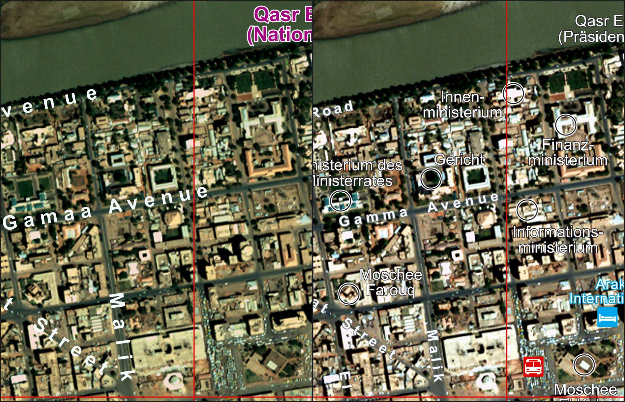
Figure 4: Changes of the cartographic design of the map

The size of lettering and of the symbols in general had to be reduced. For lettering the streets, two sizes dependent on the importance of the street were adopted. In the prototype map a circle with an outline for important buildings and a pictogram for hospitals were used. In the course of time a few pictograms, especially for hotels, airports, and railway or bus stations, were added.

In the overview maps important linear elements like main roads or railways are represented with a line symbol. In that case all possibilities of design, like double and/or broken lines, are useful for a better differentiation. Moreover, the use of two distinctive colours guarantees avoiding the problematic of legibility as described before. The only condition that lines should meet, especially if they are derived from GIS data, is that they are joined to obtain a proper symbolization.

The use of transparencies is useful together with boundary bands, or in connection with the representation of cities and towns, that can be displayed with areas, as shown in figure 5. The colour for the symbolization should be selected in a way that the symbol is recognizable, despite of the transparency, so that the content of the image under the symbol is not too much covered.

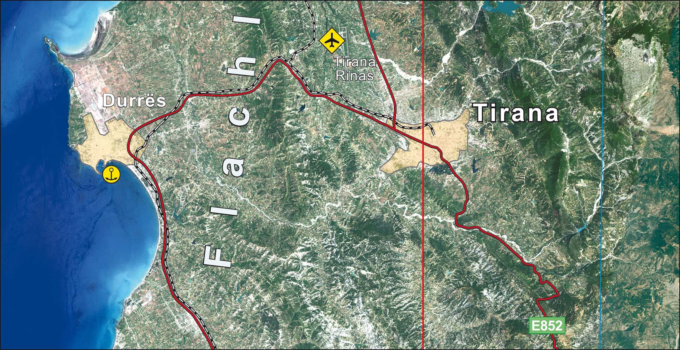
Figure 5: Cartographic design of the overview map of Albania

5 Problems of the Map Production
Figure 6 shows a part of two overlapping LANDSAT images (overlapping area marked with red lines) with a combination of the three visual bands (RGB), shot at different times. An automated colour correction did not bring the desired results, so that a manual correction was necessary. This had been done in ADOBE Photoshop, using the tools correction of tonal value, adaptation of hue and saturation, selective colour correction, brightness and contrast. Due to difficult colour conditions, the colour of the final result slipped off slightly into green, which could be accepted as a compromise, as seen in figure 5.

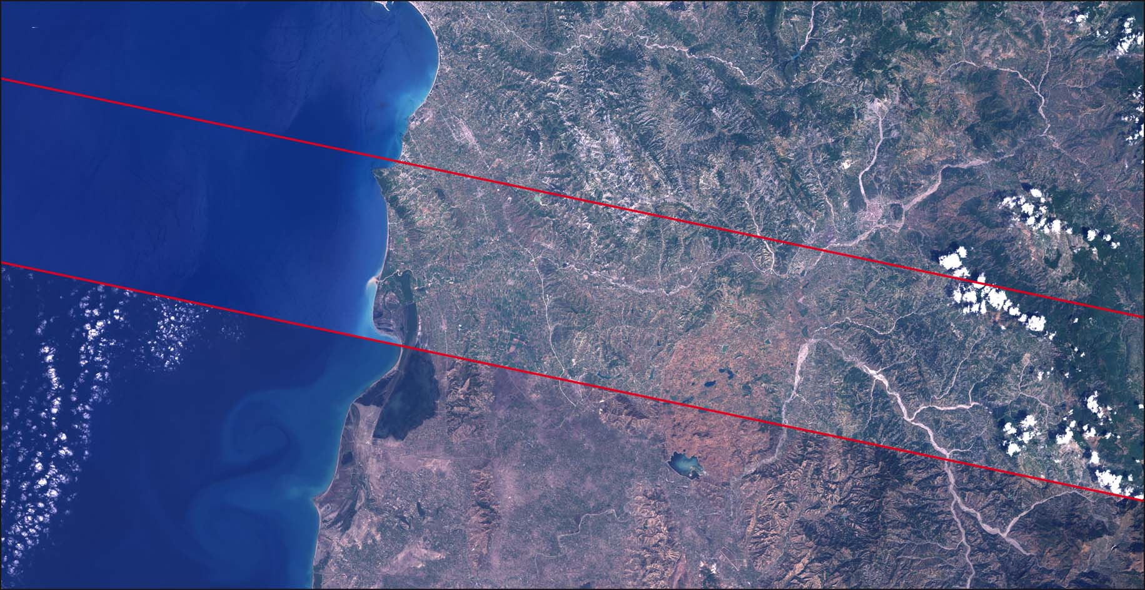
Figure 6: Mosaicking of different image scenes

Different contents, like clouds in the south-western part of the area, made a retouching of the satellite image necessary. This was realized by using the copy-stamp tool of Photoshop with the colour and structure of the surrounding parts of the sea. In addition to that, a mask of the sea with a melting transition in the overleaping area could be used. It would also be suitable to use an amplifying edge filter to improve the detail rendition of satellite images (Albertz et al., 1992).

Aggravating, during processing the satellite images, was the amount of data, which run up to nearly 2 GB and extended the processing time. Sufficient equipment of hardware is necessary for this process, especially if pan-sharpening of the satellite images has to be done.

The greatest problem concerning editorial matters is the availability of information of the processed satellite image map, if a traditional city map of good authority is hard to get hold of. Sometimes maps are available from the internet, but only with doubtful reliability, because of the missing imprint and/or date of edition. Information about the location of hotels and embassies is also available from the internet, but sometimes only in a more or less strongly schematic way. Another important aspect is the date of actuality. During the working of the satellite image of Rabat, the address of the embassy of the United Kingdom has changed. The former address could be assigned to the satellite image due to a map from the internet, while the new address could not be localized until the date of printing.

The change of the used vector drawing program had a severe effect on the cartographic processing of a satellite image map. MACROMEDIA Freehand has been bought by ADOBE. It could be expected that the maintenance and the further development of Freehand will be shut down. Besides, the cooperation of vector and raster data is probably better within the ADOBE program family, so that it is very obvious to change to ADOBE Illustrator as the vector drawing program.

The transfer of the master of the layout to ADOBE Illustrator caused no problems. The differences between these two programs are in the details. Especially the lettering offers more and better opportunities with Illustrator. Here several design elements like lines and areas with different colours, patterns and transparencies can be assigned to a text character. This is an elegant possibility to realize, for instance, an outline of text characters with a different colour. Another difference is the handling of layers, where special graphic attributes can be assigned to all elements of the layer and not only to elements of a predefined style.

6 Further Outlook
The design and the workflow of the production, together with the master of the map layout, required some already produced satellite image maps, some changes and adaptations of the cartographic design, and some experience within the cartographic production. This was sometimes a time-consuming process, especially concerning the change and the handling of the vector drawing program. But now a standardized and optimized workflow has been defined to minimize the necessary processing time. Nevertheless, some slight adaptations and developments will always be possible for further map productions.
References
Albertz, J.; Lehmann, H.; Tauch, R. (1992): Herstellung und Gestaltung hochauflösender Satelliten-Bildkarten. Kartographische Nachrichten, Heft 6, 1992.
Albertz, J. (2005): Kartographie und Fernerkundung. Begleitheft zur Ausstellung der Kommission "Kartographie und Fernerkundung", 53. Deutscher Kartographentag, Rostock, 2005.
Beckel, J.; Eisl, M. M.; Köpf, A. A. (2006): Geographie aus dem Weltraum. Der ESA Schulatlas. Mitteilungen der Österreichischen Geographischen Gesellschaft, Band 148, Wien, 2006.
Hof, A. (2007): Satellitenbildkartographie bei schwieriger Datenlage. Kartographische Nachrichten, Heft 1, 2007.
Hoffmann, A.; Lehmann, F. (2000): Vom Mars zur Erde - Die erste digitale Orthobildkarte Berlin mit Daten der Kamera HRSC-A. Kartographische Nachrichten, Heft 2, 2000.
Jiresch, E. (1991): Die Anwendung von Unbuntaufbau und Küppers Farbskala für bunte Bildkarten. Kartographische Nachrichten, Heft 4, 1991.
Kelnhofer, F. (1985): Orthophotokarten aus Weltraumbildern, dargelegt am Beispiel der Orthophotokarte 47/10 Glurns, 1 : 200 000. Mitteilungen der Österreichischen Geographischen Gesellschaft, Band 127, Wien, 1985.
Kudola, R. (2000): Setting Expectations across the Range of Image Quality. Imaging Notes, Vol 15, No 3, 2000.
Mang, R.; Häusler, H. (2006): International Handbook Military Geography. Truppendienst-Handbook, Ministry of Defence, Vienna, 2006.
Meinel, G.; Reder, J. (2001): IKONOS-Satellitenbilddaten - ein erster Erfahrungsbericht. Kartographische Nachrichten, Heft 1, 2001.
Wechselberger I. (2006): Digital Image Processing. In: International Handbook Military Geography. Truppendienst-Handbook, Ministry of Defence, Vienna, 2006.

